**Renewable sources, nuclear power, and energy storage alternatives to reduce UIUC Campus CO2 emissions**

*Fairhurst-Agosta Roberto*

[*ref3@illinois.edu*](mailto:ref3@illinois.edu)

*University of Illinois at Urbana-Champaign*

*NPRE 498 - Spring 2021*

**Introduction**

Energy is one of the most vital contributors to economic growth. In the future, economies and populations will continue to expand, and their energy demand will accompany such change. Meeting these future needs requires the development of clean energy sources to ease the increasing environmental concerns. As seen in Figure 1, electricity generation was one of the economic sectors that released the most greenhouse gases (GHGs) in the US in 2017. As carbon dioxide (CO2) is the main component in GHGs, decarbonizing electricity generation will allow us to meet the increases in energy demand and address the environmental concerns simultaneously [1].

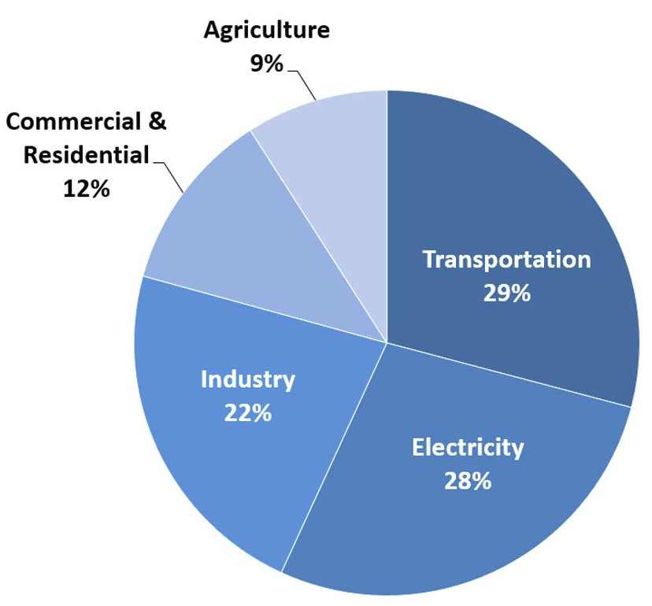

Figure 1. Total US GHG emissions by economic sector in 2017. Image reproduced from [2].

This work focuses on the decarbonization of UIUC campus grid, aligning its objectives with the Illinois Climate Action Plan (iCAP) [3-4]. In 2008, UIUC signed the American College and University Presidents’ Climate Commitment, formally committing to becoming carbon neutral as soon as possible, no later than 2050. The university developed the iCAP in 2010 as a comprehensive roadmap toward a sustainable campus environment. The iCAP defines a list of goals, objectives, and potential strategies for several topical areas:

* + Energy Conservation and Building Standards
  + Energy generation, Purchasing, and Distribution
  + Transportation
  + Water and Stormwater usage
  + Purchasing, Waste, and Recycling (Zero Waste)
  + Agriculture, Land Use, Food, and Sequestration

The main objective of this work is to analyze several electricity generation alternatives for decreasing CO2 emissions on UIUC campus. The following secondary objectives will lead to the

fulfillment of the main objective. These objectives are to understand the components of the UIUC campus grid, determine current CO2 emissions in two representative months of the year, calculate CO2 emissions for different scenarios, including the increase in wind and solar generation capacity and the addition of a nuclear reactorto the grid, and the comparison of different electricity storage mechanisms.

**UIUC Campus Grid**

Several energy sources contribute to meeting UIUC campus demand. Figure 2 displays the distribution of energy generation in 2019 from different sources. This section will describe each of them. This work considers the small scale solar component to be negligible.

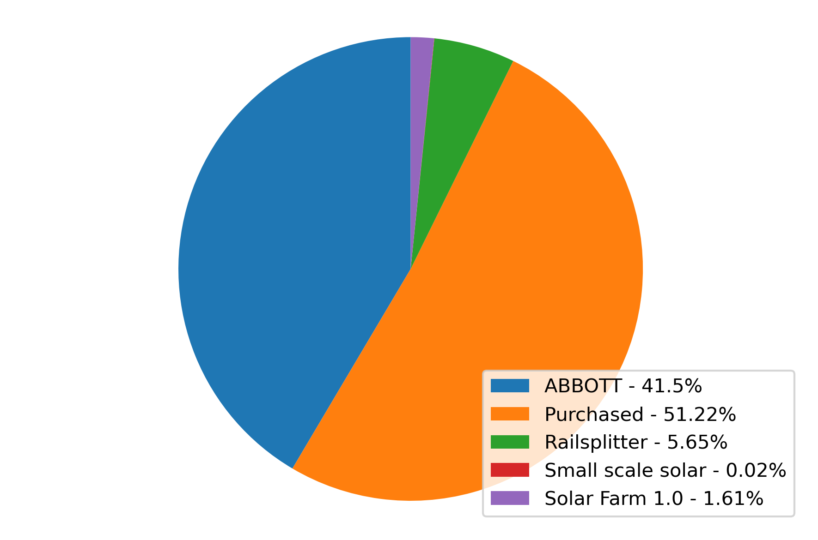

Figure 2. Electricity generation distribution in fiscal year 2019 [4].

Abbott Power Plant was built in 1941 and supplies approximately 70-75% of the campus energy demand [5-6]. The plant has two gas turbines, that can use either natural gas or fuel oil, three gas-fired boilers, that can use either natural gas or fuel oil, and three coal-fired boilers. Abbott is a cogeneration facility being able to supply campus with steam and electricity. The production of high-pressure steam spins a turbine to drive a generator and produce electricity. The low-pressure exhaust steam fulfills the space heating, water heating, and space cooling requirements from campus. Abbott’s maximum capacity is 85 MW for electricity and 800 klbs/h.

Similar to natural gas, university electricity purchases electricity with the assistance of a market advisor. The university works with Prairieland Energy, Inc. to determine volumes and price points for future purchases of electricity, with the goal of providing budget certainty as well as cost effective utilities [7].

Rail Splitter Wind Farm began commercial operation in 2009. It is Located in Tazewell and Logan Counties, north of the town of Lincoln. It has 67 wind turbines of 1.5 MW each, providing the farm a maximum power output of 100.5 MW. Starting in November 2016 the campus has been receiving a percentage-based portion of the wind-generated electricity from the Rail Splitter Wind Farm. The power purchase agreement specifies that 8.6% of the total wind generation from the farm will be sold to the university, which is expected to be an annual amount of more than 25,000 megawatt-hours (MWh). The power purchase agreement has a fixed rate for the entire 10- year PPA term [7-8].

Solar Farm 1.0 began commercial operation in 2015. The solar farm comprises 18,867 modules, which cover a land area of 20.8 acres and produce a power output of 4.68 MWac. The solar farm produces approximately 7,200 megawatt-hours (MWh) annually or approximately 2% of the annual electrical demand for the UIUC campus. Additionally, UIUC has signed an agreement to construct and operate a Solar Farm 2.0, a 54-acre 12.32 megawatt (MWdc) solar farm on university-owned property. This installation will generate approximately 20,000 MWh annually [7, 9-11].

**Nuclear reactors**

UIUC campus demand is typically smaller than 80 MW. Accordingly, the following analyses consider reactors of small capacities, such as microreactors and small modular reactors (SMRs). These reactor concepts share several features. The reactors require limited on-site preparation as their components are factory-fabricated and shipped out to the generation site. These reactors allow for black starts, being capable of starting up from an utterly de-energized state without receiving power from the grid. They can also operate in islanding mode, being able to operate connected to the grid or independently. Moreover, these reactors use passive safety systems, minimizing electrical parts [1, 12].

**Energy storage mechanisms**

This work considers two energy storage mechanisms, Li-ion batteries and hydrogen. This section briefly describes each of them and their coupling to a nuclear reactor.

The first prototype of a Li-ion battery was developed in 1985, becoming recently popular in the last two decades. Li-ion batteries are rechargeable and are commonly used in laptops and cellphones, in Electric Vehicles (EVs), in Uninterruptible Power Supplies (UPS), for applications such as computers, communication technology, and medical technology. This type of battery is characterized for its high energy density and low self-discharge. Additionally, it has a charge-discharge efficiency of 80-90%, making a good candidate for electricity storage. However, it can be a safety hazard since it contains flammable electrolytes, and if damaged or incorrectly charged can lead to explosions and fires [13-17].

The electrolysis of water is a well-known process whose commercial use began in 1890. This process produces approximately 4% of H2 worldwide. The process is ecologically clean because it does not emit GHGs. However, in comparison with other methods, electrolysis is a highly energy-demanding technology. Three electrolysis technologies exist. Alkaline-based is the most common, the most developed, and the lowest in capital cost. It has the lowest efficiency and, therefore, the highest electrical energy cost. Proton exchange membrane (PEM) electrolyzers are more efficient but more expensive than Alkaline electrolyzers. Solid Oxide Electrolysis Cells (SOEC) electrolyzers are the most electrically efficient but the least developed. SOEC technology has challenges with corrosion, seals, thermal cycling, and chrome migration. The first two technologies work with liquid water, and the latter requires high-temperature steam, so this work refers to the first two as Low-Temperature Electrolysis (LTE) and the latter as High-Temperature Electrolysis (HTE) [1].

Water electrolysis converts electric and thermal energy into chemical energy stored in hydrogen. The process enthalpy change $ΔH$ determines the required energy for the electrolysis reaction to take place:

$ΔH = ΔG + TΔS$ (1)

where $ΔH$ is the specific total energy, $ΔG$ is the specific electrical energy, and $TΔS$ is the specific thermal energy. In LTE, electricity generates the thermal energy. Hence, $ΔH$ alone determines the process’s energy requirement. $ΔH$ is equal to 60 kWh/kg-H2 considering a 67% electrical efficiency. In HTE, a high-temperature heat source is necessary to provide the thermal energy. $ΔG$ decreases with increasing temperatures, as seen in Figure 3. Decreasing the electricity requirement results in higher overall production efficiencies since heat-engine-based electrical work has a thermal efficiency of 50% or less.

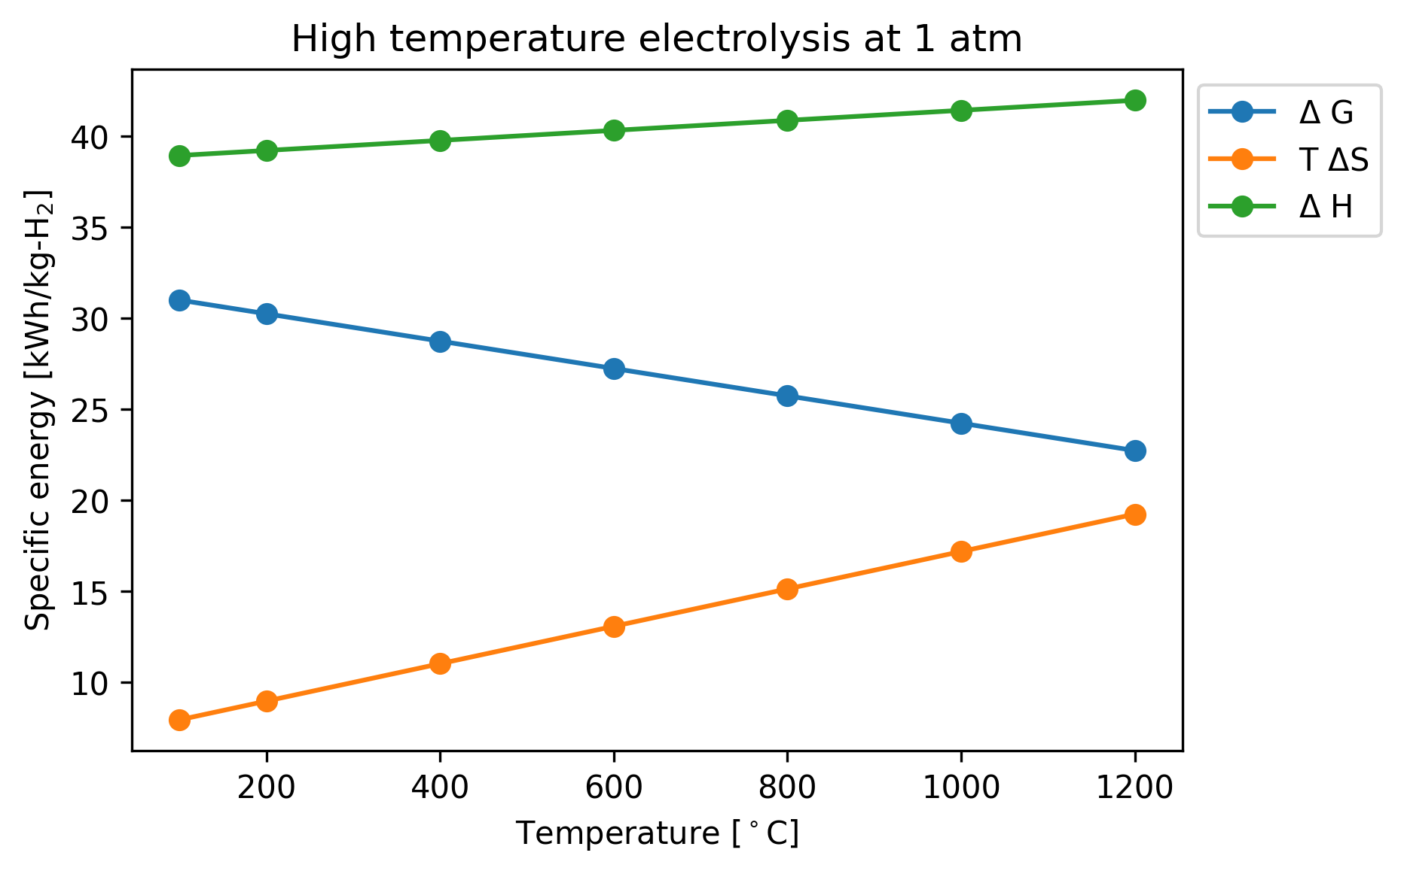

Figure 3. Energy required by electrolysis at atmospheric pressure [1].

**Methodology**

The following subsections describe the different considered scenarios.

**Scenario 0**

This scenario is the business as usual scenario, in which it is possible to calculate the current production of CO2  in two representative months of the year. The months chosen are June and January, in order to have representative months of the most demanding seasons. This scenario is the simplest one, and all the considered energy sources contribute equally to fulfill the campus total demand. The data used in this work is available from UIUC F&S per request [18]. In this and the following scenarios, Abbott and the purchased or imported electricity are considered to emit 0.26 tCO2/MW(th)h and 0.825 tCO2/MWh, respectively [3-4].

**Scenario 1**

This scenario studies the case in which the wind and solar generation capacity increase. Consequently, it is necessary to calculate the electricity production from Abbott and the imported electricity as well. For this purpose, the development of a dispatch model was necessary. Such a model, shown in Figure 4, gives priority to the different sources in the following order: renewable sources, storage mechanism, Abbott, and imports. Abbott’s electricity generation is preferred over imports because of their CO2 emissions per MWh. In Figure 4, ND corresponds to net demand, calculated by subtracting wind and solar from the total demand.

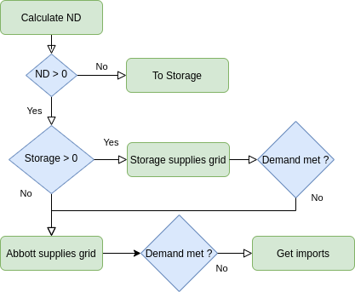

Figure 4. Scenario 1 dispatch model.

**Scenario 2**

This scenario is very similar to Scenario 1 but considers the addition of a nuclear reactor to the grid. The dispatch model is very similar to the one in Figure 4. However, the net demand is calculated subtracting wind, solar, and the reactor generation from the demand. Depending on the preferred storage mechanism, the reactor can supply the hydrogen plant with both electricity and thermal power, as shown in Figure 5.

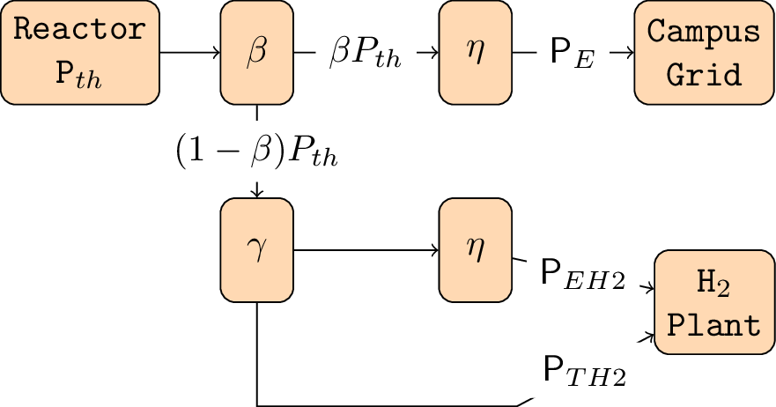

Figure 5. Diagram of a nuclear reactor coupled to a hydrogen plant [1].

**Results**

The following subsections describe the results obtained for the different considered scenarios.

**Scenario 0**

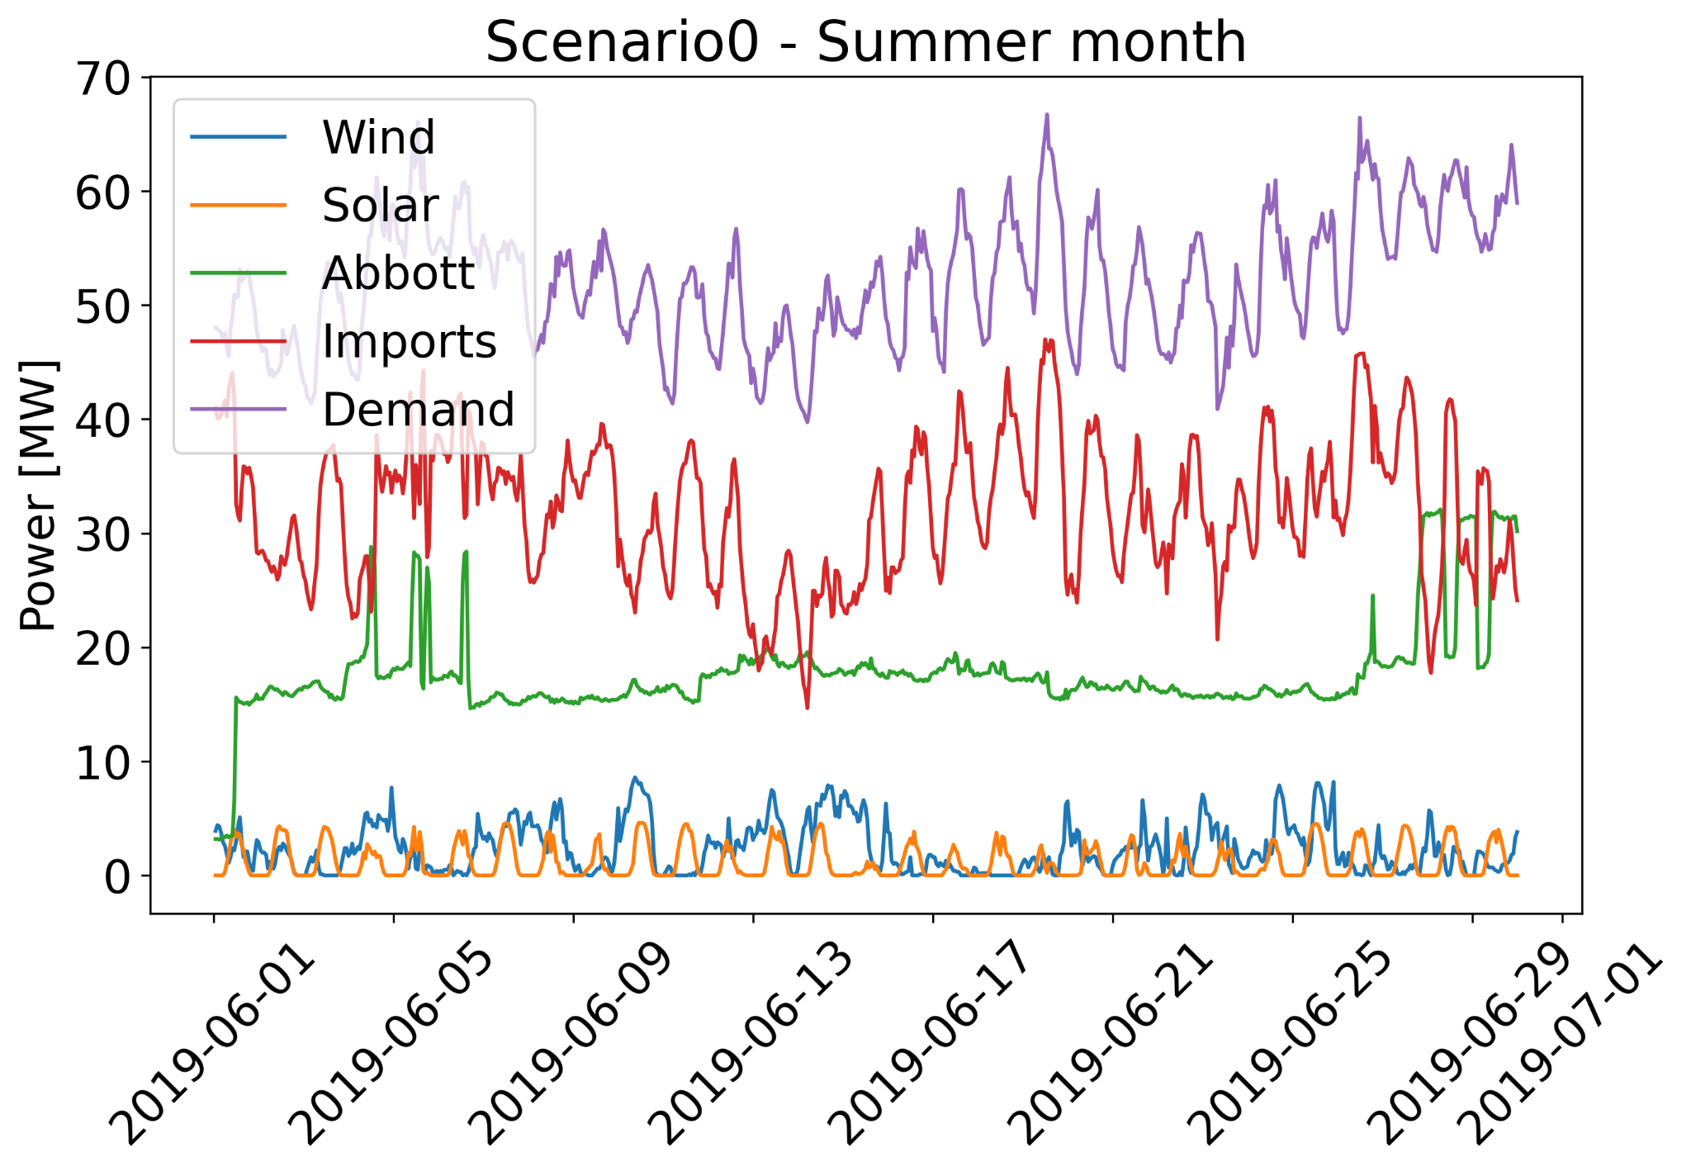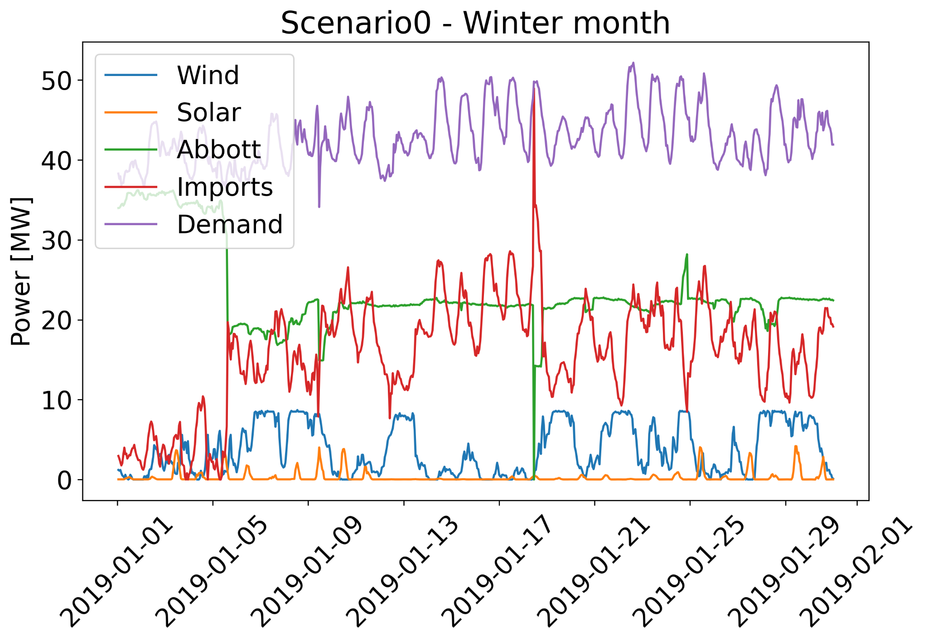

Figure 6. Scenario 0 hourly electricity distribution by source.

Table 1.Scenario 0 CO2 emissions by source.

| 103 MT CO2 | Abbott | Imports | Total |
| --- | --- | --- | --- |
| Winter | 6.6 | 8.5 | 15.1 |
| Summer | 4.8 | 16.7 | 21.5 |

Figure 6 and Table 1 display the results for Scenario 0. Winter total demand is lower than in summer, making emissions lower for the former. This could be caused by a lower occupation of campus during January. Future work may focus on February to avoid this bias.

**Scenario 1**

Figure 7 displays an example of hourly electricity distribution by source. In this case, the chosen storage mechanism is Li-ion batteries. Figures 8 and 9 show the CO2 emissions and the respective wind, solar, and storage capacities for the different increase capacity factors. These figures show that Abbott has enough capacity to supply campus without the need for importing electricity. However, this study focuses on CO2 emissions and not on the economical side of the electricity supply. For the summer month, eliminating the electricity imports already reduces the emissions in almost a half.

This scenario considers a linear increase in the renewable capacities, as shown in Figures 8 and 9, the CO2 reduction is also linear as long as no energy storage is required. Once, the energy storage is needed, the higher the charge-discharge efficiency, the more linear the reduction is. This scenario achieves higher CO2 reductions by using Li-ion batteries.

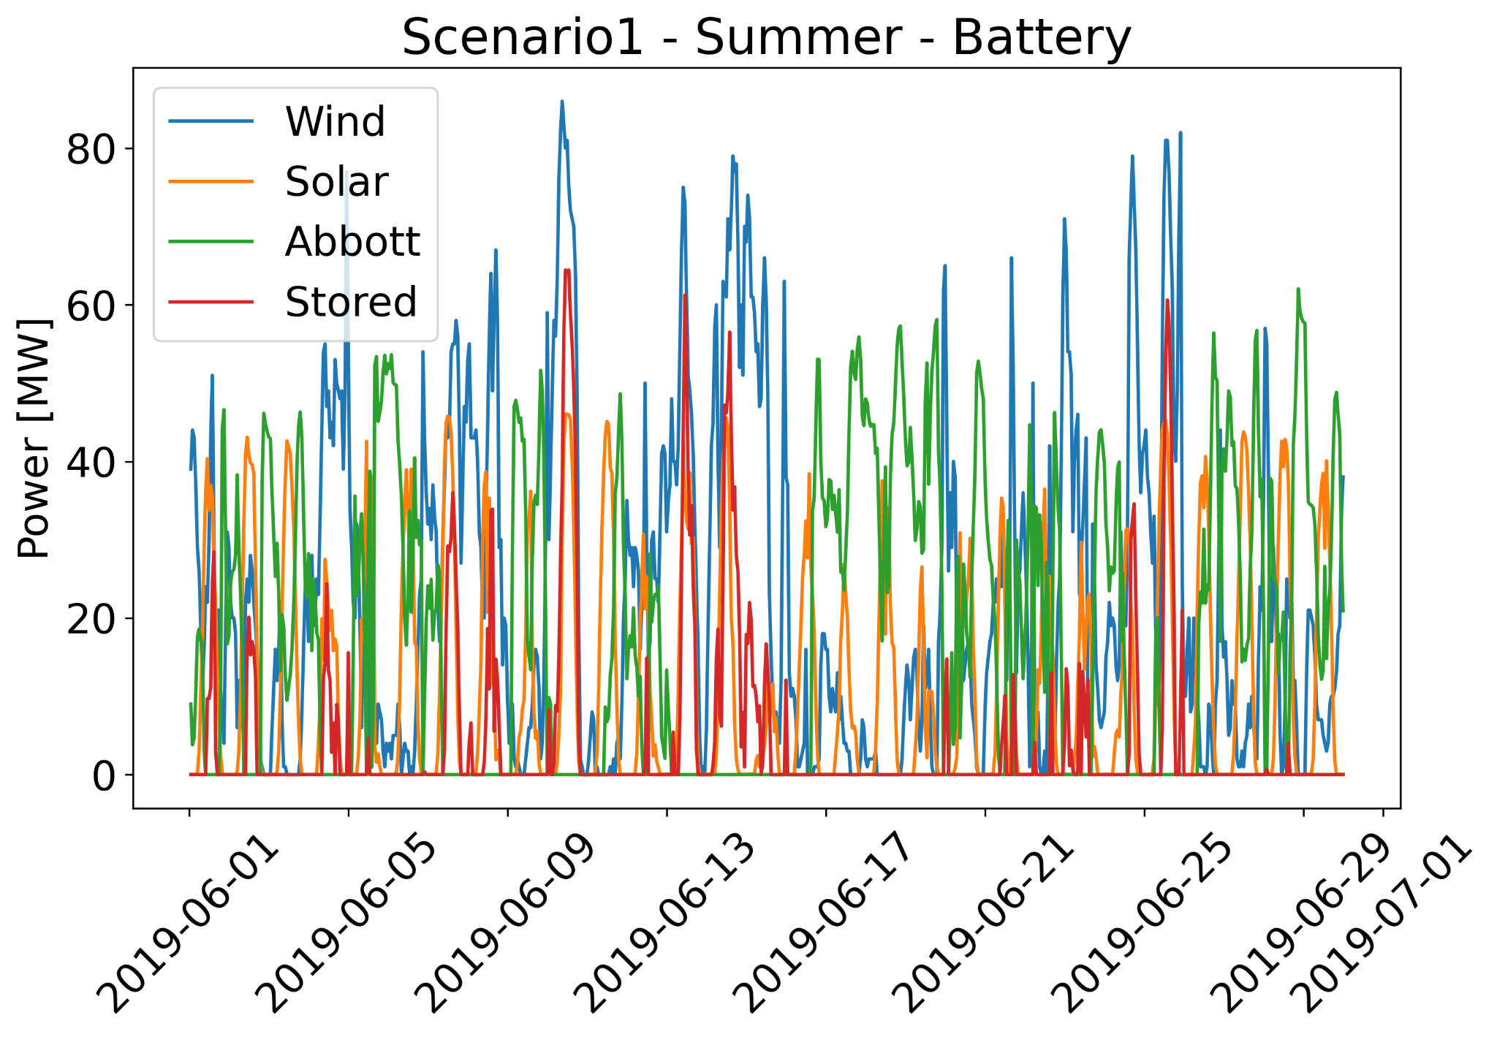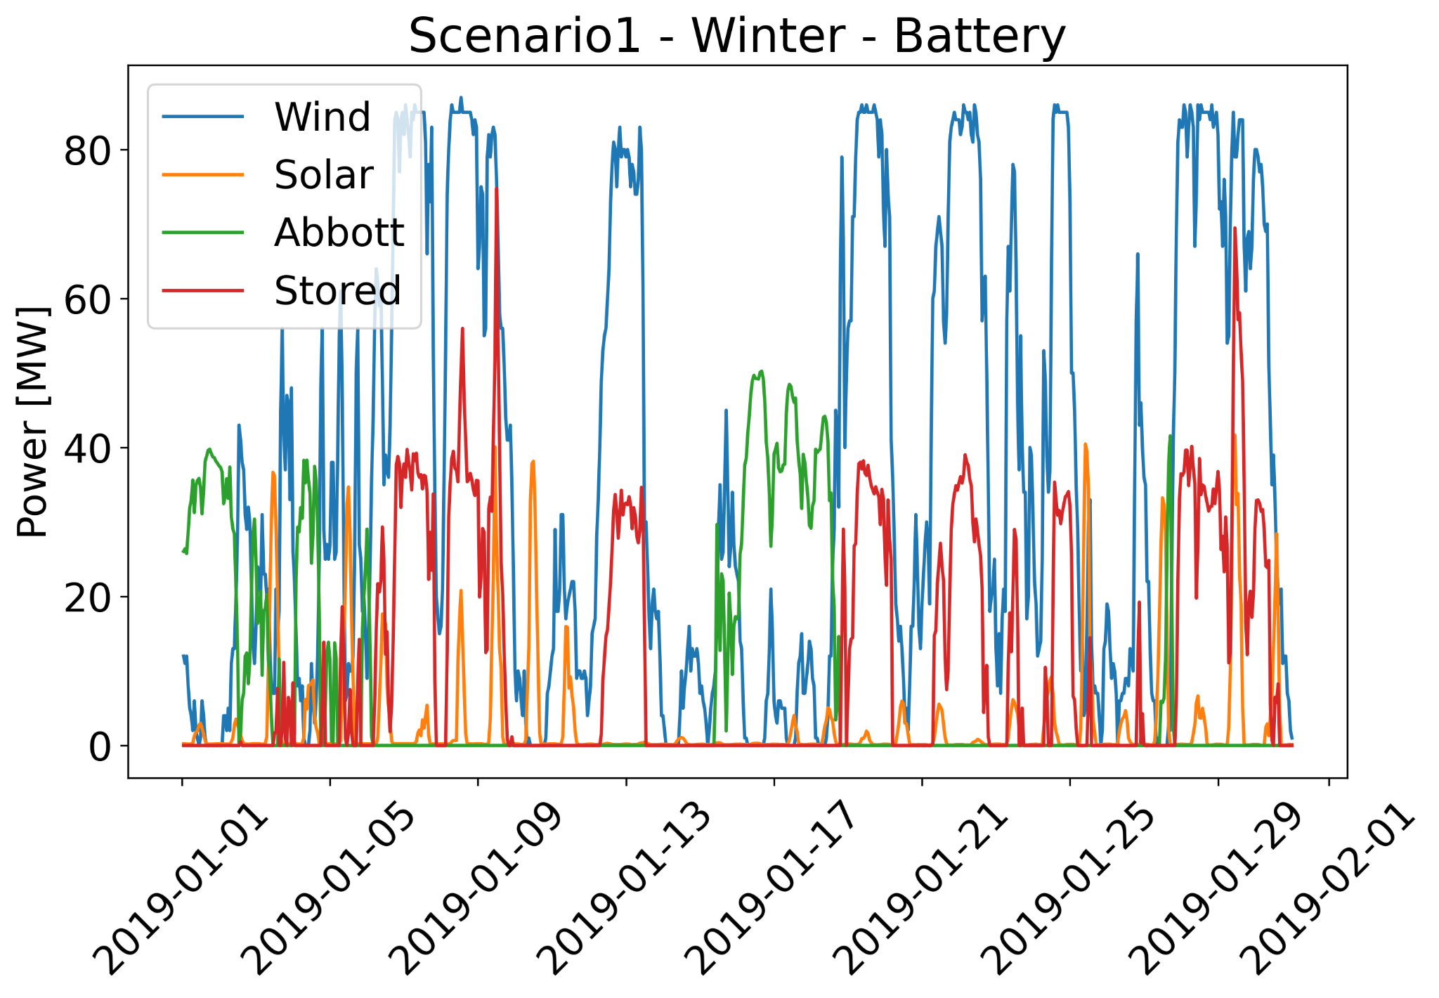

Figure 7. Scenario 1 hourly electricity distribution by source for an increase capacity factor of 10.

Figure 8. CO2 emissions, wind, solar, and storage capacities for different increase capacity factors in the summer month.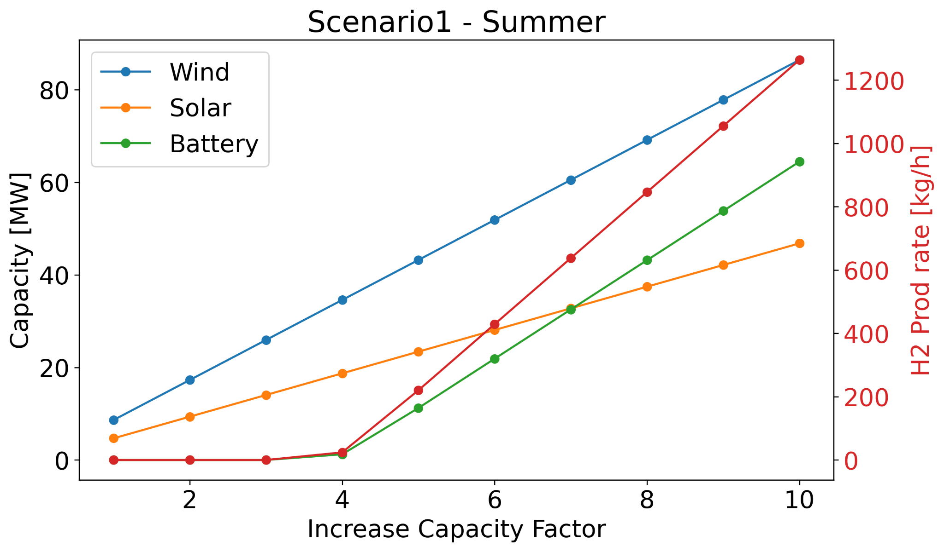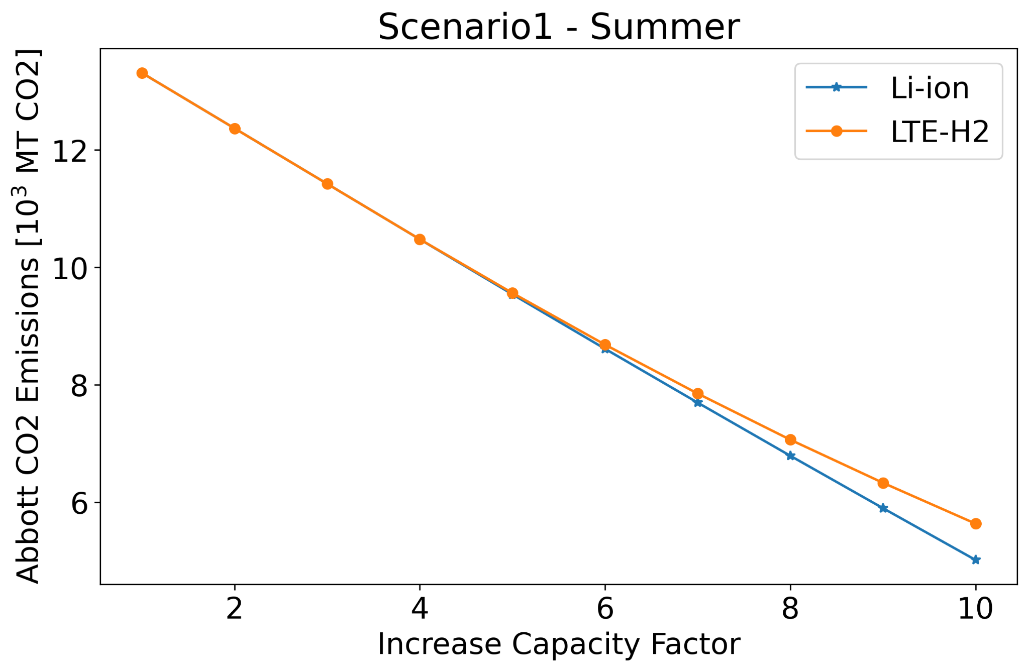

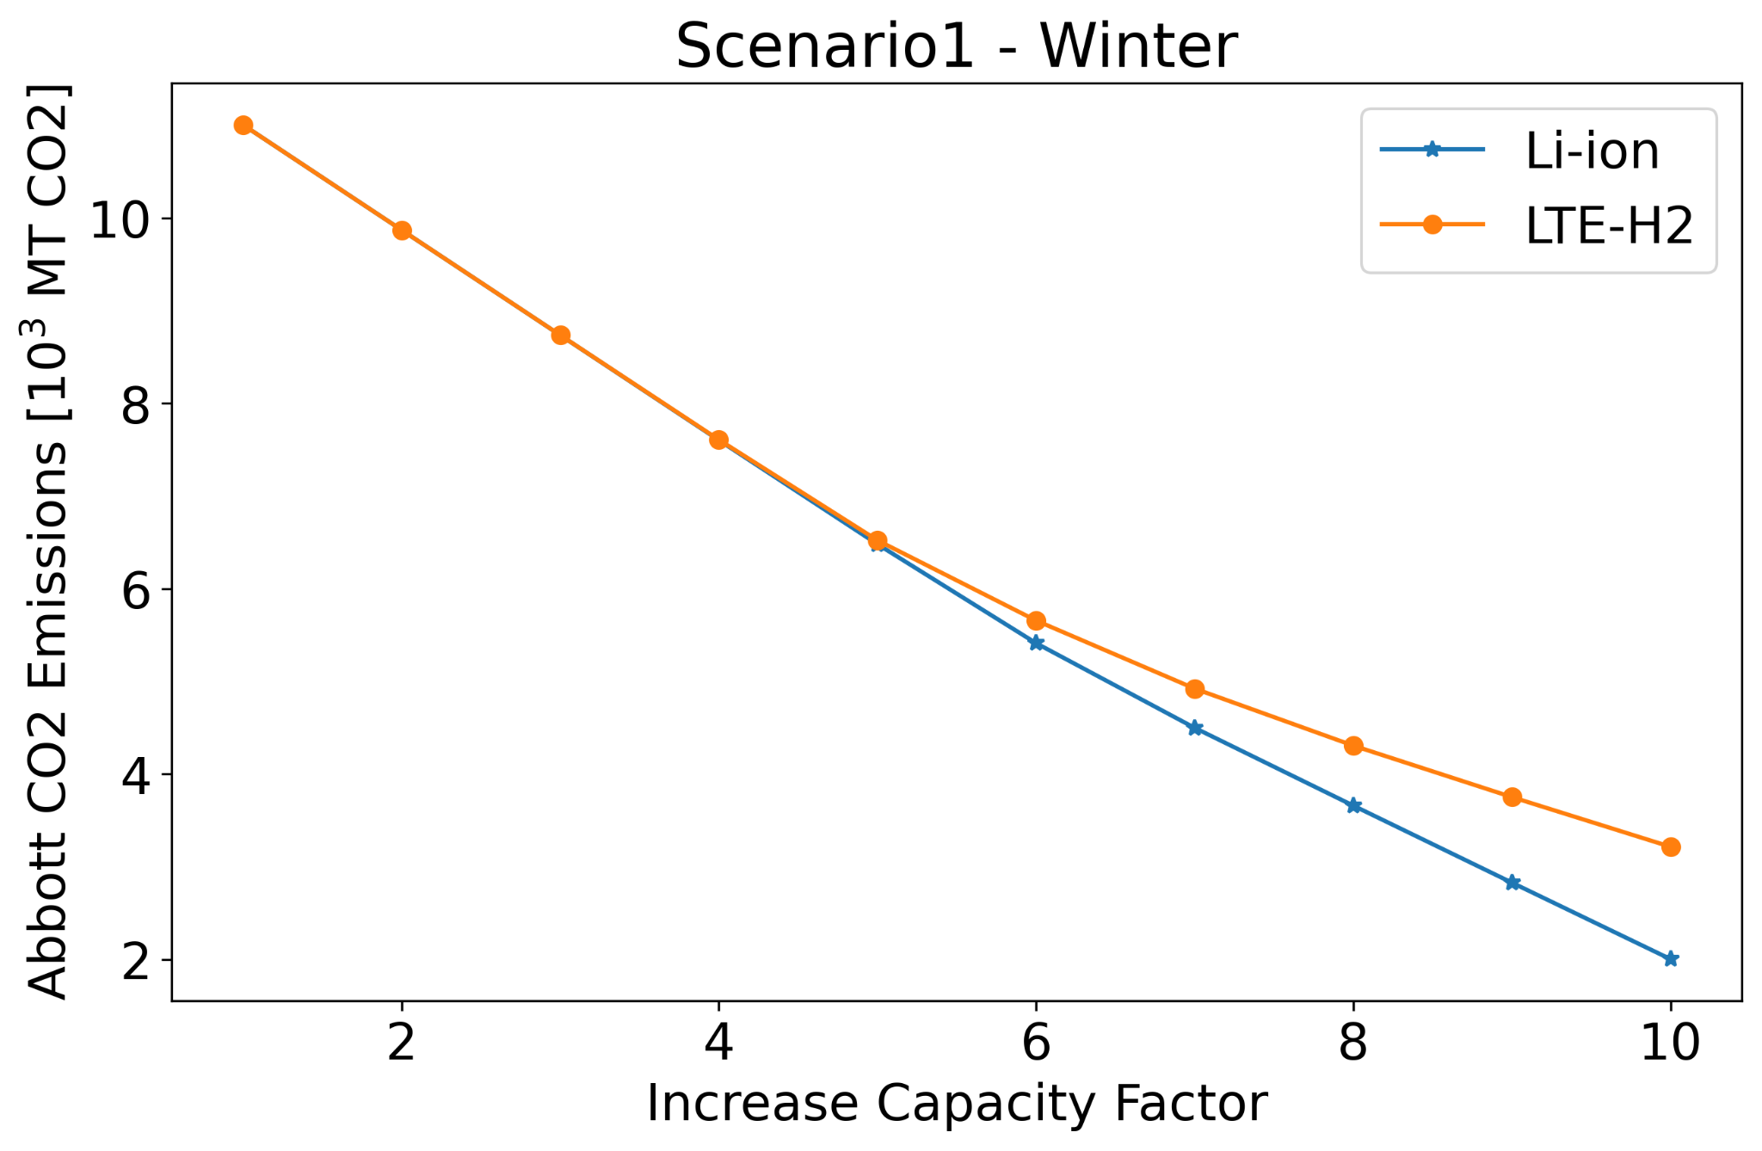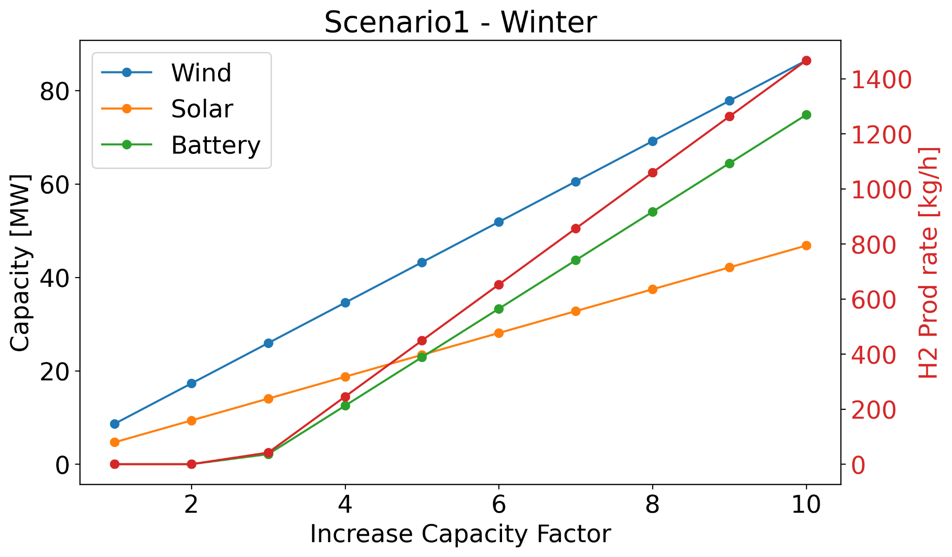

Figure 9. CO2 emissions, wind, solar, and storage capacities for different increase capacity factors in the winter month.

**Scenario 2**

Figure 10 displays an example of hourly electricity distribution by source. In this case, the chosen storage mechanisms are hydrogen produced from HTE and Li-ion batteries. Hydrogen production from HTE is limited by the reactor power. As HTE requires high temperatures, hydrogen by this method can only be used when the net demand is lower in magnitude than the reactor power. If the net demand was negative and with a larger magnitude than the reactor power, a secondary storage mechanism becomes necessary. The case in Figure 10 uses Li-ion batteries as secondary storage.

Figure 10. Scenario 2 hourly electricity distribution by source for an increase capacity factor of 10. The storage mechanisms are HTE-H2 and Li-ion batteries.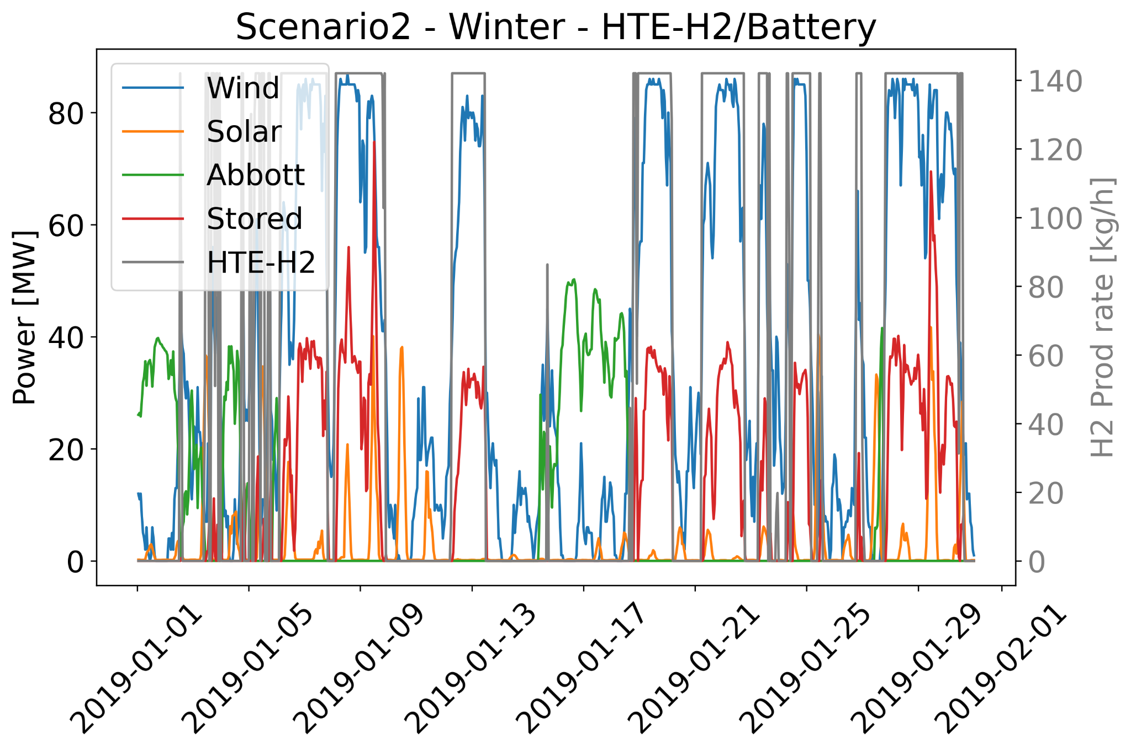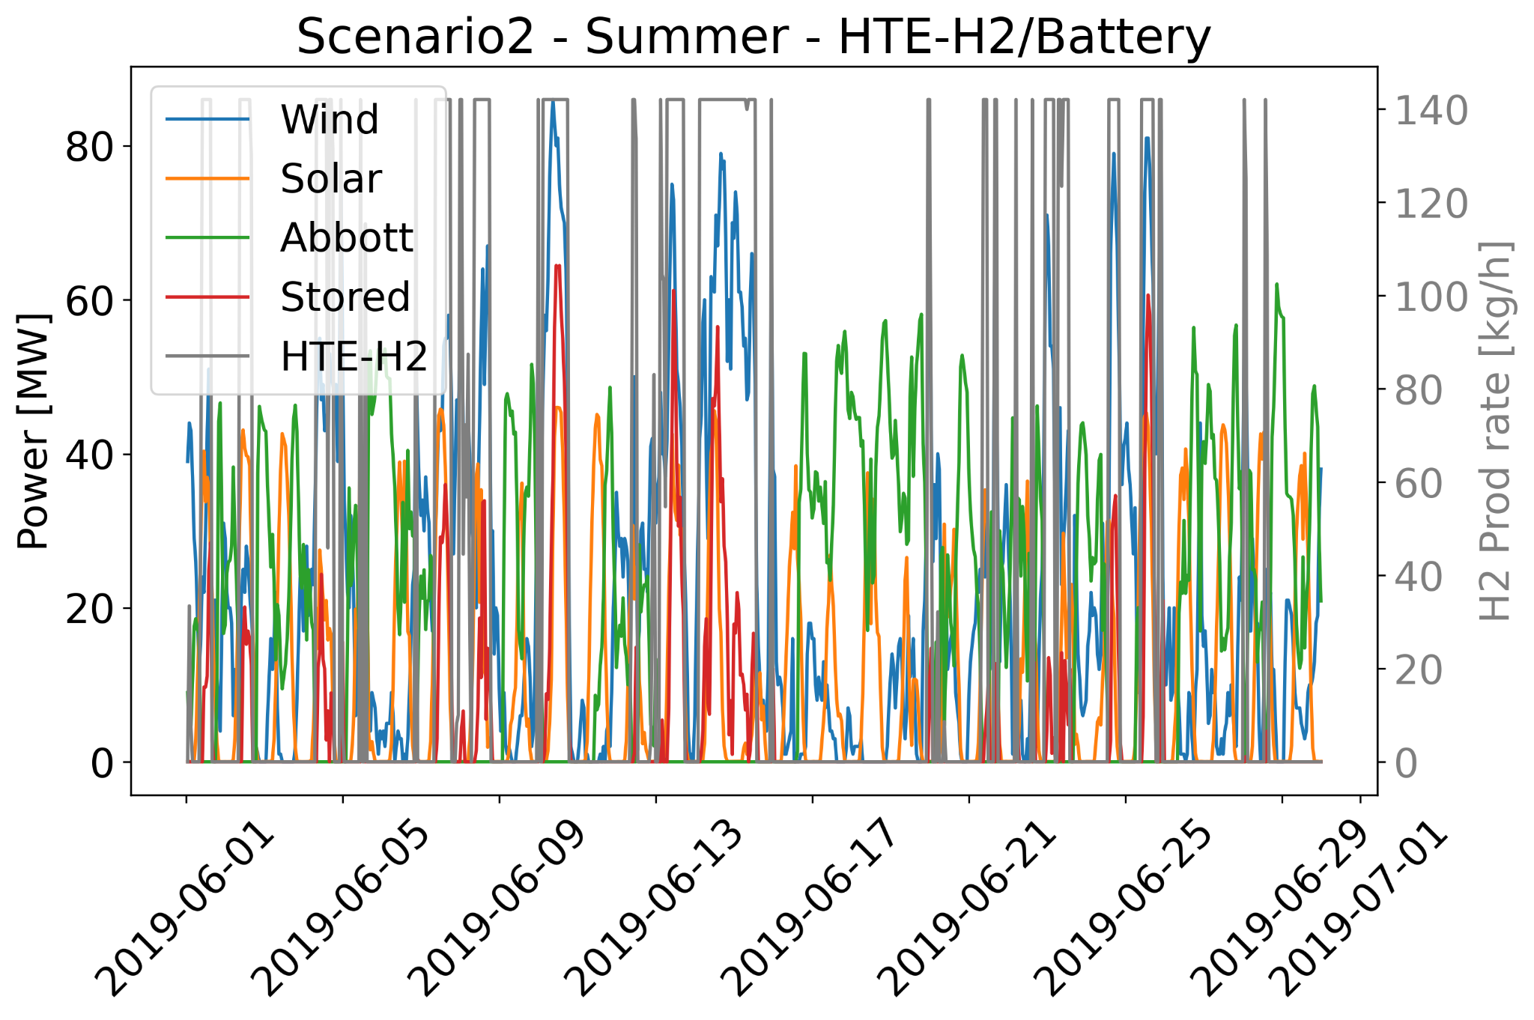

Figures 11 and 12 show the CO2 emissions and the respective wind, solar, and storage capacities for the different increase capacity factors. Ten cases were considered in this analysis. 5 cases using different storage mechanisms and 2 different reactor powers 10 and 20 MWth. The electrical storage mechanisms, Li-ion and LTE, consider two reactor outlet temperatures as well. The reason for this is that conventional Light Water Reactors (outlet temperature of 300 ℃) have efficiencies around 33% while Gen-IV reactors, for example Very High Temperature Reactors (outlet temperature of 850 ℃), can achieve higher efficiencies around 48% [1]. The HTE-H2 case considers LTE-H2 as the secondary storage mechanism.

The results show that using HTE-H2 does not show great advantages, highlighting that a high outlet temperature is still desirable but only for attaining greater efficiencies. Additionally, the use of the nuclear reactor considerably reduces the CO2 emissions but does not eliminate them. Further analyses are required, in which the reactor capacity should be increased even further.

Figure 11. CO2 emissions, wind, solar, and storage capacities for different increase capacity factors in the summer month.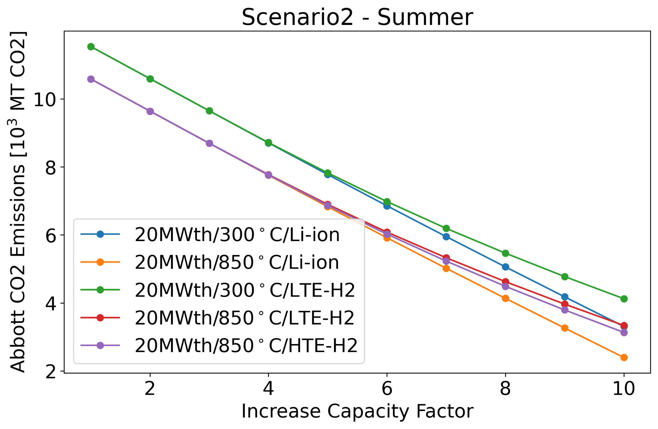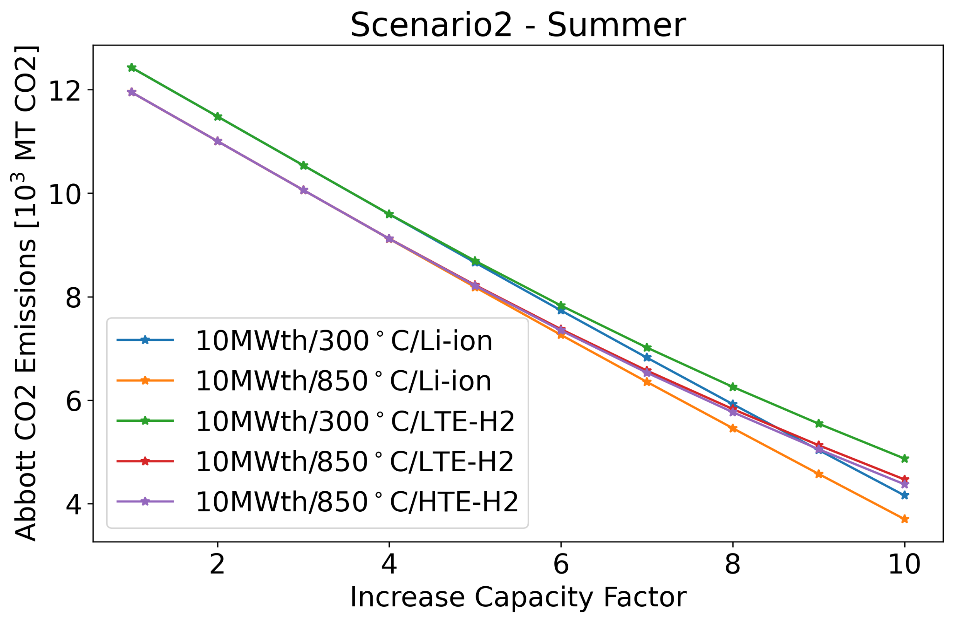

Figure 12. CO2 emissions, wind, solar, and storage capacities for different increase capacity factors in the winter month.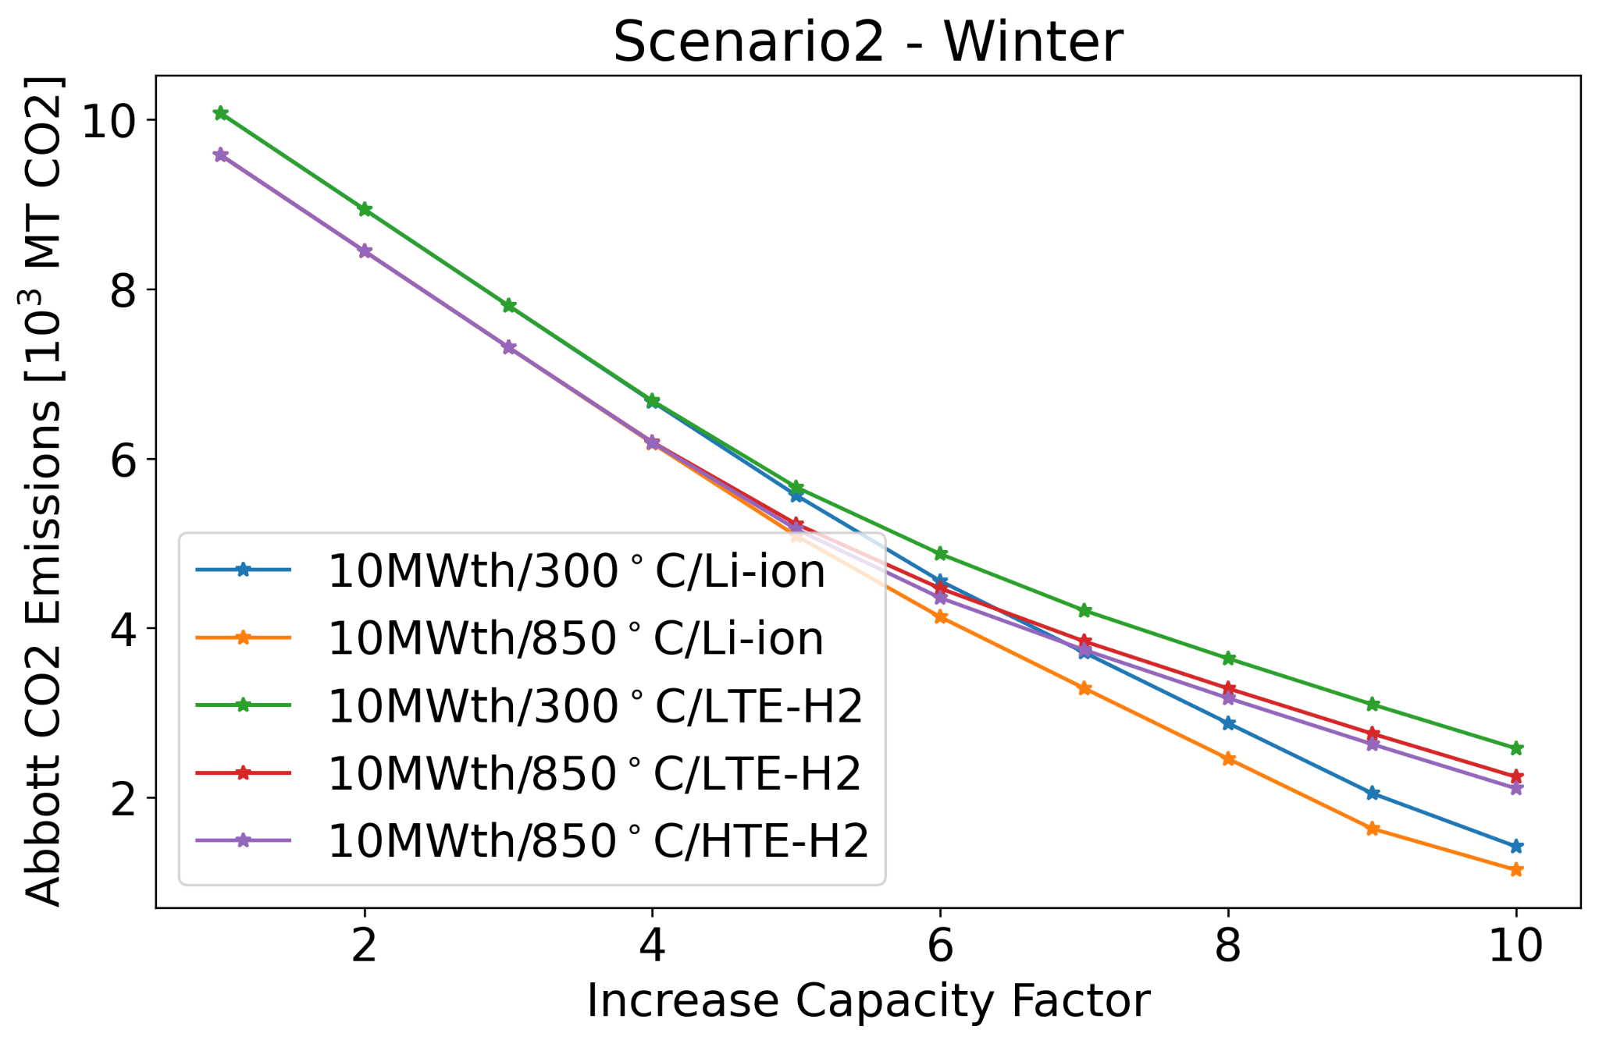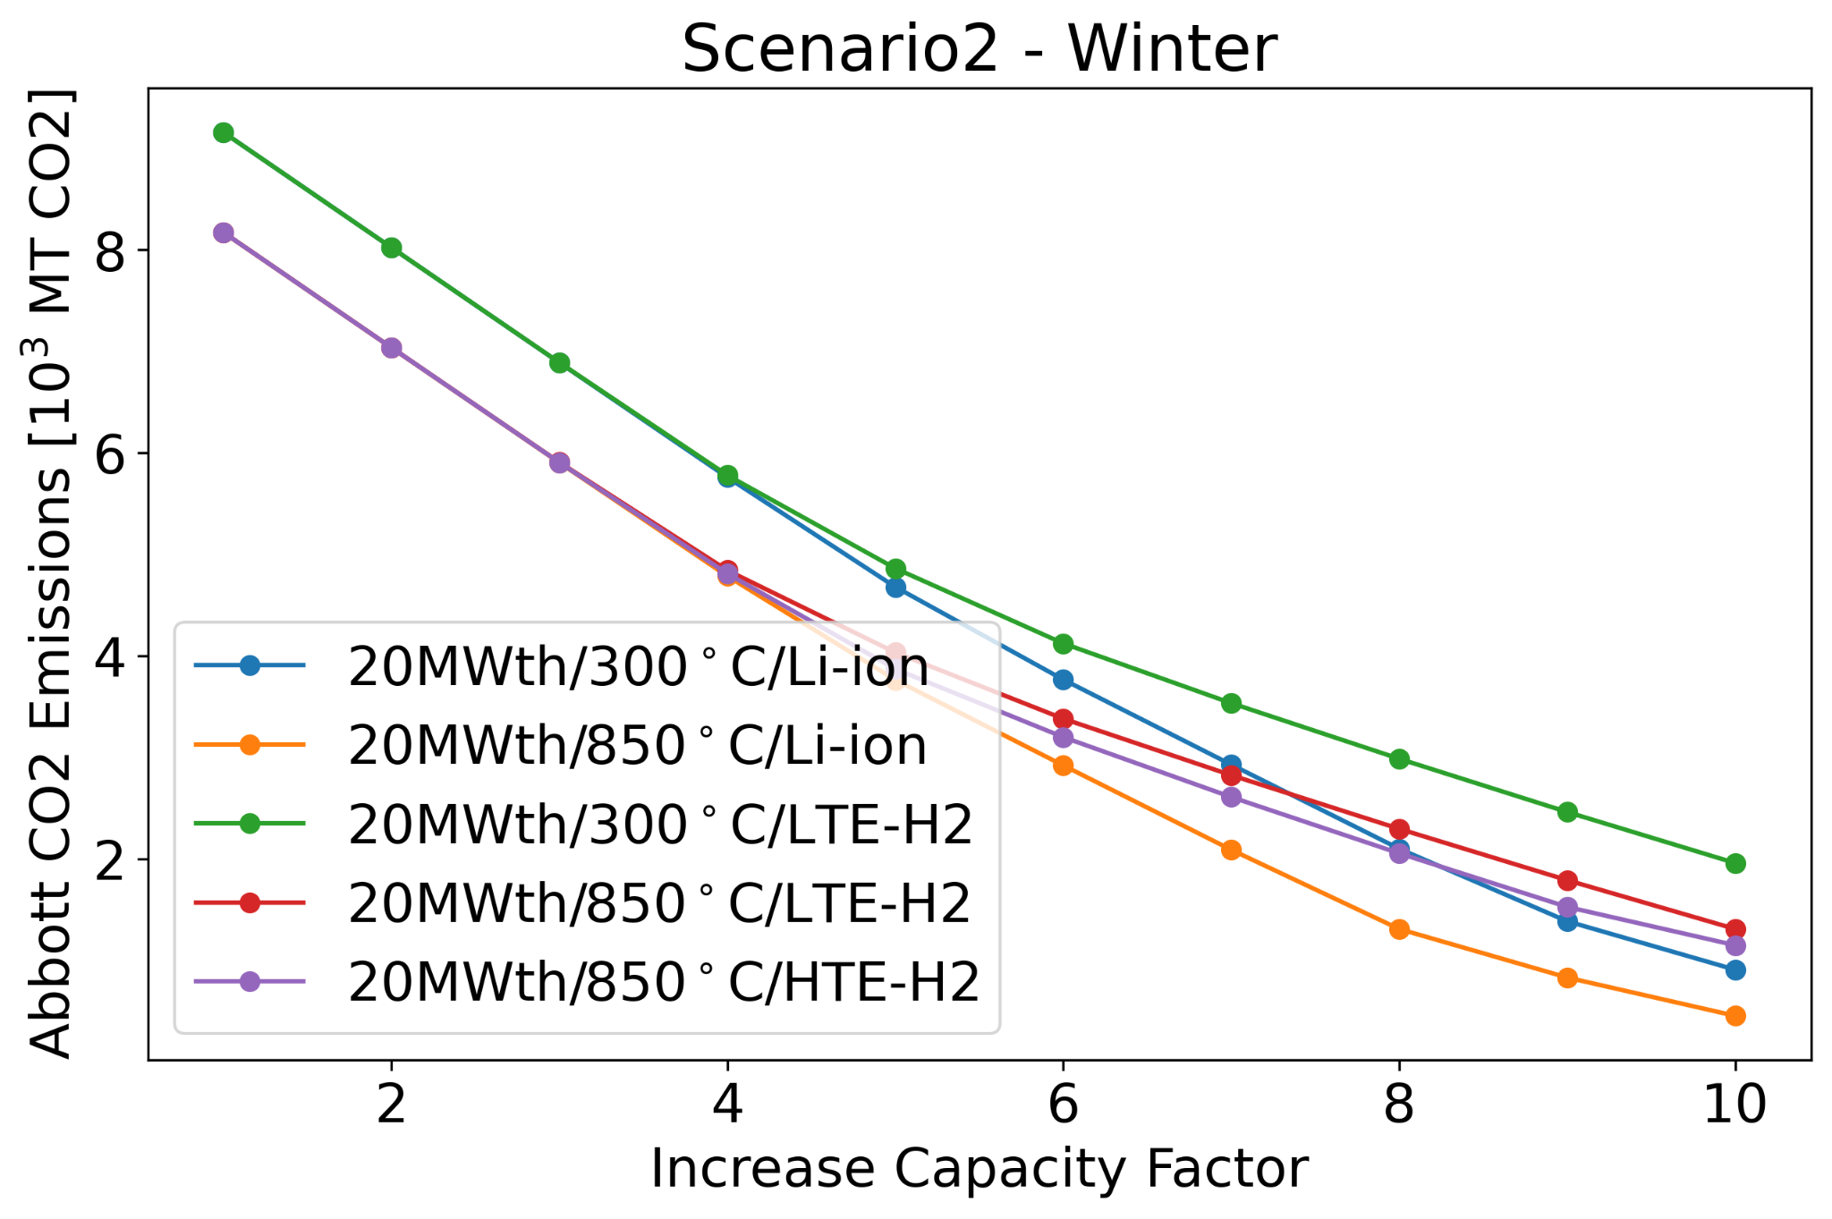

**Conclusions**

The UIUC campus grid is a good example of a diverse microgrid, in which different energy sources need to work symbiotically to fulfill campus demand. This work focused on reducing the carbon emissions on campus, and several approaches were contemplated.

Some of the main takeaways from Scenario 1 is that decreasing the imported electricity has a strong impact on the CO2 emissions. However, this work considers that Abbott has a maximum capacity of 85 MW and that all that capacity is available if needed. As a cogeneration plant Abbott’s steam production may limit the maximum available electric capacity, requiring the import of electricity. Additionally, the results showed that increasing the capacity of renewables linearly decreases CO2 emissions as long as no storage mechanism is needed.

With respect to Scenario 2, larger reactor capacities reduce further the CO2 emissions. Additionally, the presence of a gen-IV reactor, with higher outlet temperatures and, hence, higher efficiencies, increases the electrical capacity reducing even further the CO2 emissions. As seen in the results section, the HTE-H2 production is limited by the size of the reactor, requiring a secondary storage mechanism. Finally, Li-ion batteries are the most efficient storage mechanism.

**Acknowledgements**

I would like to thank Sam Dotson and Lucas Woodrich for putting together most of the data that was used in this work. This research was performed using funding received from the DOE Office of Nuclear Energy’s University Program (Project 20-19693, DE-NE0008972) ’Evaluation of micro-reactor requirements and performance in an existing well-characterized micro-grid’.

**References**

1. Fairhurst-Agosta R. MULTI-PHYSICS AND TECHNICAL ANALYSIS OF HIGH-TEMPERATURE GAS-COOLED REACTORS FOR HYDROGEN PRODUCTION. MS Thesis. University of Illinois at Urbana-Champaign. 2020. <https://www.ideals.illinois.edu/handle/2142/109439>
2. US EPA. Sources of Greenhouse Gas Emissions. Jan. 2020. <https://www.epa.gov/ghgemissions/sources-greenhouse-gas-emissions>.
3. iSEE. Illinois Climate Action Plan 2015. University of Illinois at Urbana-Champaign, Urbana, IL, 2015. <https://icap.sustainability.illinois.edu/files/project/2634/2015iCAPweb.pdf>
4. iSEE. Illinois Climate Action Plan 2020. University of Illinois at Urbana-Champaign, Urbana, IL, 2020. <https://icap.sustainability.illinois.edu/files/project/5293/iCAP-2020-FINAL-WEB.pdf>
5. UIUC F&S. Abbott Power Plant. Accessed on 05/2021. <https://fs.illinois.edu/services/utilities-energy/production/abbott-power-plant>
6. UIUC F&S. Abbott Power Plant Brochure. Accessed on 05/2021. <https://fs.illinois.edu/docs/default-source/utilities-energy/abbottbrofinal.pdf?sfvrsn=90b1f9ea_4>
7. UIUC F&S. Energy Management Plan. December 2015. <https://fs.illinois.edu/docs/default-source/utilities-energy/final-energy-management-plan.pdf?sfvrsn=92a1d8ea_4>
8. RailSplitter. Illinois: Rail Splitter Wind Farm. 2016.

<https://icap.sustainability.illinois.edu/files/project/2235/RailSplitter-Wind%20Farm-9.6.16.pdf>

1. <https://fs.illinois.edu/services/utilities-energy/production/renewable-energy>
2. <https://fs.illinois.edu/docs/default-source/utilities-energy/solar-farm-project-fact-sheet_with-faqs_104171bbba4c36b8160c2ad00ff2500358aeb.pdf?sfvrsn=813ac4ea_0>
3. <https://icap.sustainability.illinois.edu/project/solar-farm-20>
4. <https://www.energy.gov/ne/downloads/ultimate-fast-facts-guide-nuclear-energy>
5. <http://large.stanford.edu/courses/2010/ph240/sun1/>
6. <https://www.ornl.gov/news/new-class-cobalt-free-cathodes-could-enhance-energy-density-next-gen-lithium-ion-batteries>
7. <https://relionbattery.com/blog/the-seven-top-uses-for-rechargeable-lithium-ion-batteries>
8. <https://en.wikipedia.org/wiki/Lithium-ion_battery#Battery_life>
9. <https://www.tesla.com/videos/powerpack-hornsdale?redirect=no>
10. UIUC F&S. Private Communications. 2019. 2020.